**Lecture # 13:**

**Objective:**

* Database Connectivity (1 Layer)

Introduction to Database Connect (simple)

# Database

create database student use student

create table StdInfo (

ID bigint,

StdName nvarchar(30)

)

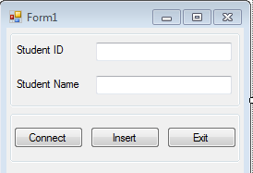

# Presentation Layer

using System.Data.SqlClient; namespace IntroToSqlConSimple

{ public partial class Form1 : Form

{ public Form1()

{ InitializeComponent(); } SqlConnection sqlCon = null;

string strCon = "Integrated Security=SSPI;Persist Security Info=False;Initial Catalog=student";

private void btnConnect_Click(object sender, EventArgs e)

{ try

{ sqlCon = new SqlConnection(strCon);

if (sqlCon.State == ConnectionState.Closed)

|  |  |  |
| --- | --- | --- |
| {  } | sqlCon.Open(); lblCon.Text = "Connected"; | } |
| catch | (Exception ex) |  |
| { | MessageBox.Show(ex.Message); | } } |

private void btnInsert_Click(object sender, EventArgs e)

{ try

{

string query = "insert into StdInfo (ID, StdName) values (" + txtID.Text + ", '" + txtStdName.Text + "')";

SqlCommand sqlCmd = new SqlCommand(query, sqlCon); int rowAffec=sqlCmd.ExecuteNonQuery(); MessageBox.Show("Rows Affected: " + rowAffec);

}

catch (Exception ex)

{ MessageBox.Show(ex.Message); } } private void btnExit_Click(object sender, EventArgs e)

{ Application.Exit(); } }}